Command Center
Application Layer Architecture
Architecture Approach, Design Principles, Considerations & Tradeoffs
Frontend (React / TypeScript) + Backend (Python)
Reference Document for Application Architecture Standards

Purpose & Scope
This document defines the application-layer architecture approach followed for the Command Center, covering both the frontend (React/TypeScript) client and the backend (Python) services. The intent is to provide a reusable reference pattern that future projects can follow when building client-server applications on this stack.
The goal is to ensure that every application built on this stack is consistent, modular, secure, observable, and maintainable — regardless of which team builds it or which specific business domain it serves.
The Command Center is used as the reference implementation for this pattern. Other applications should reuse the same layering, naming conventions, folder structure, and cross-cutting standards, but they do not need to reuse the same repository, environment, or hosting configuration as the Command Center.
Standard: Reuse the architecture pattern, layering, and engineering conventions — not necessarily the same physical repository or environment.

1. Architecture Approach
The Command Center follows a layered client-server architecture. The frontend is a React/TypeScript single-page application; the backend is a Python service exposing an API layer, an agent/orchestration layer, and a data access layer. Each side is organized so that responsibilities are isolated into predictable, single-purpose folders.

1.1 Reference Application Architecture Pattern
At a high level, a request flows through the following logical layers:
- Client / Presentation — React components and pages render the UI and capture user interaction.
- Client API Layer — Encapsulates all HTTP calls to the backend; no component should call fetch/axios directly.
- Client State Layer — Holds application state (store) so UI state is predictable and shareable across features.
- Backend API / Routing — Receives HTTP requests, validates input, and delegates to the service/agent layer.
- Backend Service / Agent Layer — Contains business logic and, for the Command Center, agentic/orchestration workflows.
- Backend Repository Layer — Abstracts data persistence so services never talk to the database directly.
- Data Store — The underlying database / storage the repository layer reads from and writes to.
- Cross-cutting — Auth, configuration, middleware, and logging apply across every layer above.

1.2 Frontend Architecture
The frontend is built as a modular React application. Each top-level folder under src/ owns one concern, so a feature can be extended without reaching into unrelated parts of the codebase.

Folder Responsibilities
- api — Centralised API client(s) and request/response handling for backend communication.
- app — Application shell — root providers, routing, and top-level layout composition.
- assets / icons — Static assets such as images and icon sets.
- auth — Authentication state, guarded routes, and session/token handling.
- components — Shared, reusable presentational components used across features.
- config — Environment-driven application configuration.
- constants — Static values shared across the app (routes, enums, labels).
- dummy — Mock/sample data used for local development and UI prototyping.
- features — Feature-scoped modules — each business capability grouped with its own components/logic.
- store — Centralised application state management.
- styles — Global styles and shared style utilities.
- tests — Unit and integration test suites.
- theme — Design tokens — colours, typography, spacing for consistent theming.
- main.tsx / env.d.ts — Application entry point and environment type declarations.

1.3 Backend Architecture
The backend is organised around a service-oriented structure that separates request handling, orchestration, business logic, and data access.

Folder Responsibilities
- api — Route/endpoint definitions — the entry point for every incoming request.
- agents — Agentic/orchestration logic specific to the Command Center's AI-driven workflows.
- core — Application configuration, startup wiring, and shared infrastructure concerns.
- models — Request/response and data models (schema definitions).
- repositories — Data access layer — the only layer permitted to talk to the data store.
- services — Business logic that orchestrates repositories and agents on behalf of the API layer.
- main.py — Application entry point.
Consideration: the current backend structure (agents / api / core / repositories / services) has evolved from the pattern originally documented in the Backend Developer Manual (routers / controllers / middleware / utils). This evolution is intentional and reflects the move toward agentic workflows, but the manual should be refreshed so onboarding documentation matches the codebase — see Section 3.2.

2. Design Principles
The following principles apply uniformly to the frontend and backend. Each principle states the standard, and how the Command Center currently implements it.

2.1 Modularity & Separation of Concerns
Standard: each layer has one responsibility; layers communicate through well-defined interfaces only.
- Frontend — features/ isolates business capabilities; components/ stays presentation-only; api/ is the sole HTTP boundary.
- Backend — api/ handles routing only; services/ holds logic; repositories/ is the sole data-access boundary.

2.2 Reusability
Standard: common capabilities are built once and shared, not duplicated per feature.
- Frontend — Shared UI in components/, shared tokens in theme/, shared config in config/ and constants/.
- Backend — Shared business rules live in services/; shared orchestration patterns live in agents/.

2.3 Consistency & Naming Conventions
Consistent naming lets any developer predict where something lives and what a name means without reading the implementation.

Frontend (React/TypeScript)
Element | Convention | Example
Files | kebab-case | user-profile-card.tsx
Components | PascalCase | DashboardHeader
Functions / variables | camelCase | fetchUserData, setUserInfo
Constants / enums | UPPER_SNAKE_CASE / PascalCase | API_URL
Boolean state/props | is / has / should prefix | isModalOpen, hasError
Event handlers | handle / on prefix | handleInputChange, onButtonClick
Hooks & utilities | get / set / is / has / should / use prefix | useCustomHook, getFormattedDate
HOCs | with prefix, camelCase | withAuth, withTheme
Context providers | PascalCase, Provider/Consumer suffix | ThemeProvider

Backend (Python)
Element | Convention | Example
Files | snake_case | users_router.py
Classes | PascalCase | UsersController
Variables | snake_case | var_user_id
Return variables | var_ prefix | var_user_name
Temporary variables | temp_var_ prefix | temp_var_user_id
Constants | SCREAMING_SNAKE_CASE | DB_HOST, DB_PORT
Functions | snake_case, fn_ prefix | fn_get_users
Helper functions | help_fn_ prefix | help_fn_create_user

2.4 Resiliency & Error Handling
Standard: the application degrades gracefully instead of crashing outright when a dependency fails.
- Frontend — API layer centralises error handling so failed requests surface a consistent, user-safe message.
- Backend — try/except blocks around I/O and external calls; errors are translated into consistent API responses rather than leaking stack traces.

2.5 Security & Access Control
Standard: least-privilege access; secrets are never hard-coded or committed.
- Frontend — auth/ owns session and token handling; guarded routes prevent unauthorised UI access.
- Backend — Credentials are environment-driven (.env, excluded from version control); DB access is scoped to the repository layer only.

2.6 Observability & Logging
Standard: meaningful runtime events are captured to diagnose issues without reproducing them locally.
- Frontend — Client-side errors and key user actions should be logged/traced centrally (recommended next step — see Section 3.3).
- Backend — Each module maintains a change tracker; structured logging around service/agent execution is recommended for production readiness.

2.7 Maintainability & Documentation
Standard: code is self-documenting and covered by tests; conventions are written down, not tribal knowledge.
- Frontend — tests/ holds unit/integration coverage; naming conventions above keep intent obvious from the name alone.
- Backend — Docstrings on functions/classes, descriptive commit messages, and a maintained nomenclature reference (see Backend Nomenclature).

3. Considerations & Tradeoffs
This section captures the deliberate tradeoffs behind the current structure, and the open items future contributors should be aware of.

3.1 Frontend Considerations

Feature-based vs. layer-based folders
- Tradeoff — features/ groups by capability (fast to extend, some duplication across features) vs. a pure layered structure (less duplication, more cross-file jumping).
- Recommendation — Keep feature-based grouping; move truly shared logic into components/ or a shared/ utility as it emerges.

dummy/ mock data
- Tradeoff — Speeds up UI development without a live backend, but risks drifting out of sync with real API contracts.
- Recommendation — Generate dummy data from the same types/schemas used for real API responses.

Centralised store vs. local state
- Tradeoff — A single store simplifies cross-feature state sharing but can become a bottleneck if over-used for local-only UI state.
- Recommendation — Reserve store/ for state that is genuinely shared; keep component-local state in the component.

Testing coverage
- Tradeoff — tests/ exists as a top-level folder; coverage depth was not visible from the current structure alone.
- Recommendation — Track coverage explicitly and gate merges on a minimum threshold.

3.2 Backend Considerations

Agent-based structure vs. documented MVC pattern
- Tradeoff — The Backend Developer Manual describes routers/controllers/middleware/utils; the live codebase uses agents/api/core/repositories/services. The newer structure suits agentic workflows better but the manual is now out of date.
- Recommendation — Update the Backend Developer Manual to reflect the current folder structure so onboarding stays accurate.

Repository pattern
- Tradeoff — Adds an abstraction layer between services and the database, costing some boilerplate for stronger testability and easier storage swaps.
- Recommendation — Keep the pattern; it pays off as the data layer grows.

Secrets in .env
- Tradeoff — Simple for local development, but plaintext .env files are a weaker control than a managed secret store as the team and environments grow.
- Recommendation — Move to a managed secrets store (e.g. a vault or cloud secret manager) before production scale-up.

Agents as a first-class layer
- Tradeoff — Distinct from a conventional MVC backend; gives the Command Center a clear home for orchestration logic, at the cost of being a less familiar pattern to new contributors.
- Recommendation — Document the agent layer's contract (inputs/outputs, how it calls services) explicitly.

3.3 Operational Readiness Checklist
Before a production release, the following should be confirmed for both frontend and backend:
- Deployment — A repeatable, documented deployment process (build + release steps) exists for both frontend and backend.
- Environments — Dev / Test / UAT / Prod separation, with environment-specific configuration (not hard-coded values).
- Secrets — Stored outside source control; rotated on a defined schedule.
- Monitoring & Logging — Centralised logging for backend services and, at minimum, error tracking for the frontend.
- Access control — Auth flows and role-based access validated end-to-end.
- Testing — Unit and integration tests passing in CI before merge; manual QA sign-off for release candidates.
- Documentation — Developer manuals and nomenclature guides kept in sync with the actual codebase.
- Support ownership — A clear owner defined for incident response on each layer.

3.4 Standard-by-Standard Summary

Reusability
Current state: shared components, config, and services exist per layer. Recommendation: extract cross-feature logic into shared modules as duplication appears.

Consistency
Current state: naming conventions documented for both frontend and backend. Recommendation: keep the nomenclature docs as the single source of truth and review them during code review.

Resiliency
Current state: basic try/except handling; no formal retry policy documented. Recommendation: define a standard retry/backoff approach for backend calls to external dependencies.

Security
Current state: auth handled client-side; secrets via .env on the backend. Recommendation: move secrets to a managed store and document RBAC rules explicitly.

Observability
Current state: not yet formalised. Recommendation: introduce structured logging and, ideally, centralised error tracking / APM.

Operational Readiness
Current state: folder structures are consistent; deployment and monitoring are not yet documented. Recommendation: complete the readiness checklist in Section 3.3 before production release.

3.5 Final Architecture Principle
Build every Command Center feature — and every future application on this stack — using the same layering, naming, and cross-cutting standards described in this document. Teams should customise business logic, features, and agent workflows freely, but should not recreate foundational patterns for API structure, state management, security, or data access.
This keeps every application on the stack faster to onboard into, easier to review, safer to operate, and simpler to extend.

4. Reference: Repository Folder Structures
The screenshots below are the actual folder structures the architecture in Section 1 is based on, captured directly from the frontend and backend repositories.

4.1 Frontend Folder Structure
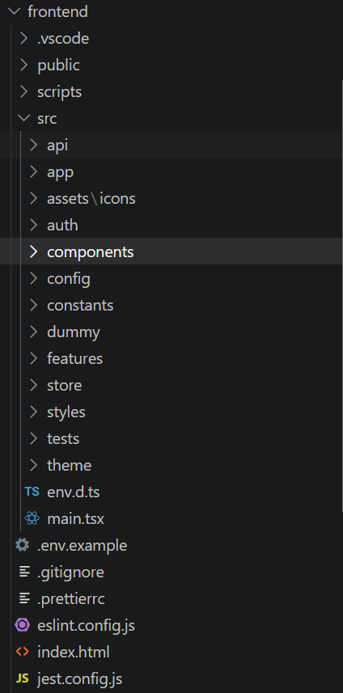
Frontend — src/ folder structure

4.2 Backend Folder Structure
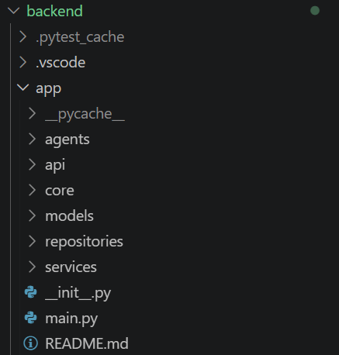
Backend — app/ folder structure

